SLO: Our 26/27 season team
The Supporter Liaison Officer (SLO) team will start their sixth season in August 2026, looking to expand further as we head into the new season.
Click HERE to view the CUSG announcement about the restructuring of the SLO role in 2021. SLO: New team appointed for the new season | Carlisle United Football Club
SLO Simon Clarkson said “There is a real buzz around the city in anticipation of the new season. I am delighted that all the home team of meeters and greeters are staying on and we will look to keep evolving, so as to provide a great match day experience at Brunton Park. A special mention to Keith Elliott who provides excellent support as part of a social media services, ensuring that fans are as informed as possible.”
So, let us introduce you to the 2026/27 team that sees Claire Burgess again in the away SLO, providing a friendly face as a point of contact for our fans at away games:

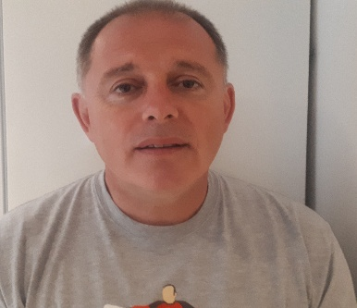

Supporter Liaison Officer - Simon Clarkson
Tell us about yourself - I moved to Carlisle in 1985 and immediately started supporting the Blues. Work took me down south at the turn of the century where I joined the London Branch.
I returned to Carlisle in 2015 and became a season ticket holder in the Paddock. I was the chair of CUSG, which helped me develop relationships with reps from supporters’ groups and staff at the club.
Favourite player - Dean Walling.
What attracts you to the role - I like a challenge, and this role supports improving the level of engagement between the fans and the club. I want to have open dialogue with fans, listen to what needs to be improved, and then work with others to make the match day experience better for fans.
Mobile – 07891 779 015 (matchdays only)
Email address – slo@carlisleunited.co.uk
Twitter – @CUFCSLO

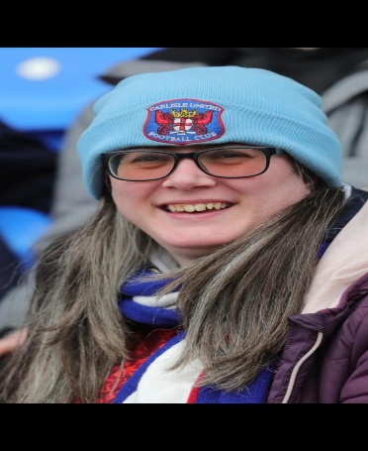

Away Supporter Liaison Officer – Claire Burgess
Tell us about yourself - I have lived in Carlisle all my life and it was not until I was in secondary school when half of the class was Carlisle United supporters. We had a scrap book in year 7 up to year 11 keeping memories and half the class in year 7, after being asked wanted the 1996/97 Carlisle United team photo. It was a week later I was hooked as a Carlisle fan after being told stories and asked why I was not a supporter. I liked football but did not have a team, so choose Carlisle United over my family Everton/Liverpool. I used to be a first aider with St. John Ambulance helping on matchdays and in 2006 called it a day to "relax" as a supporter and I would not have it any other way.
Favourite player: Zigor Aranalde
What attracts you to the role: I enjoy going to away games. It is nice to liaise with the home slo and inform the supporters of the nearest pubs, train station, buses etc to get to the game and to enjoy the experience of what the away clubs have to offer in the fan zone. I will be available on away match days giving updates to where to collect your tickets from and any enquiries supporters may have. I am always happy to help.
Twitter – @CUFCSLO


Meeter and greeter – Iain McNee
Tell us about yourself - My first game was a 3-0 home win in 1973/74 against Notts County. I was lucky enough to have a season ticket during the 1974/75 season. My favourite game at Brunton Park was beating Newcastle 3-1 in 1982/83, and the most disappointing game was losing to Fulham 0-1 in the FA Cup Quarter Final in 1975.
Favourite player – John Gorman
What attracts you to the role - I enjoy volunteering at Brunton Park, meeting new supporters, and hopefully making their visit a little easier if I can help answering any questions.



Meeter and greeter – Nigel Hunter
Tell us about yourself - I was born in Carlisle in the late 50’s, with a strong family base in the Warwick Road area. My great aunt had been mayor of Carlisle, received the freedom of the city, and had a nursing home named after her. The affinity with Carlisle was strong from an early age. A move to Yorkshire at an early age did not ruin the chance of celebrating Carlisle being top of the old League One. 30 years later, back in the north east, I was able now to introduce my son to the Carlisle United rollercoaster.
The conference play-off final became the catalyst to us both becoming season ticket holders. The joy of winning League Two was only enhanced by my son, being one of the flag bearers on the pitch, declaring us as champions.
Favourite player – Stan Bowles.
What attracts you to the role – Four years on since my retirement it continues to be wonderful to reunite with the people and club that hold a special place in my heart. I hope I can be part of a team that takes the club to it’s true potential.

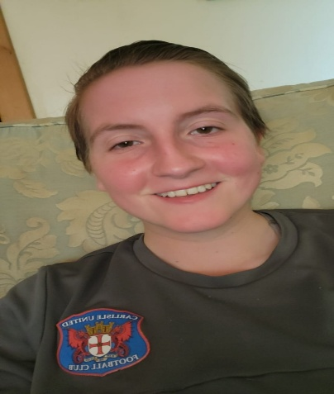

Meeter and greeter – Alicia Messenger
Tell us about yourself - my name is Alicia, and I was the first female to join the SLO team, I am local and have supported the club since I was 5. I play football for Carlisle United ladies since I was 17 and this puts a big smile on my face every time I play. My best memory at Carlisle United was when we got promoted to league one at Wembley.
Favourite player - Jon Mellish
What attracts you to the role - I enjoy meeting new people at Brunton Park and having a chat with them. I enjoy the atmosphere and the way everyone congregates to meet the players and have signatures and photos with them. I like to help fans with any issues they face.


Meeter and greeter - Neil Park
Tell us about yourself - I’ve supported CUFC since 1968. As a teenager I saw our team grow, culminating in the awesome 74/75 season - top of the (Premier) League for a week! My best memories as a supporter are seeing Jimmy Glass score his legendary goal and going to the six Football League Trophy finals.
Favourite player - Stan Bowles.
What attracts you to the role – I have been doing the meeter and greeter role for seven seasons and love it. To meet the fans on a match day and help in any way I can, is just me giving a little bit back for all the great times I have had as a supporter. I cover the Fan Zone and enjoy helping fans with any issues.

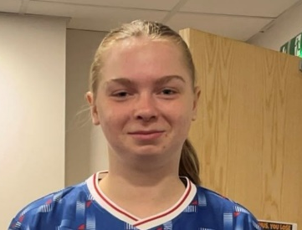
Meeter and greeter – Jess Cleasby
Tell us about yourself - I have played for Carlisle United ladies for a few years now and I really enjoy it. It has helped me socialise and helped not just my physical health but my mental health as-well.
Favourite player – Cameron Harper
What attracts you to the role: I like seeing the players and having photos done with them and I love how the children and the adults always leave with smiles on their faces I am based around the fan zone where I can help people if they have an enquiry.

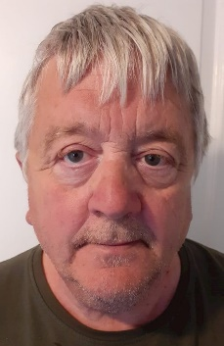
Meeter and greeter - Jimmy Slater
Tell us about yourself - I have been a supporter since I was 5. My best memory of supporting the Blues was watching Twinkletoes running on the pitch as a boy and then travelling to the finals at Wembley. My favourite past manager was Bob Stokoe.
Favourite player - Hughie McIlmoyle.
What attracts you to the role - My usual match day area is the away turnstiles. I enjoy chatting to and helping away fans, who always appreciate the chance to ask questions. It is great to be able to help fans who often have had a long journey.

